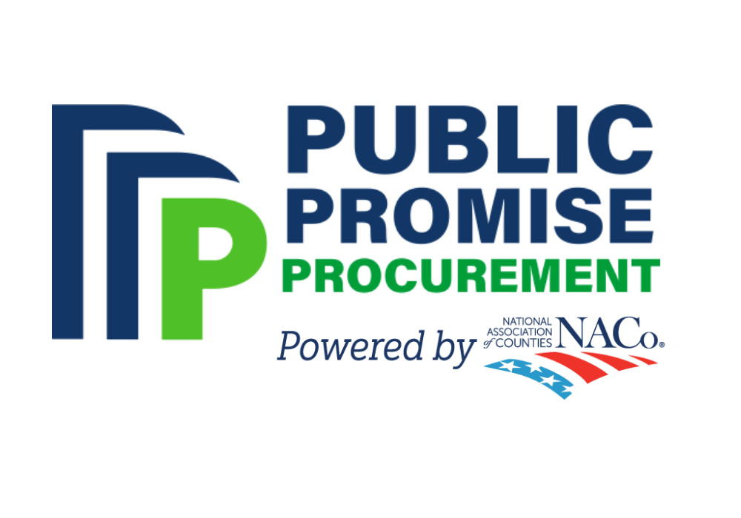OFFICIAL NYSAC ANNOUNCEMNT

To: New York Counties

From: Steve Acquario, Executive Director, NYSAC

Subject: NACo Public Promise Procurement’s Cost-Savings &

Value-Added Solutions for Communities

As a dedicated partner in advancing New York counties, I’m excited to announce NYSAC’s new collaboration with the National Association of Counties’ Public Promise Procurement (NACo PPP) enterprise. This partnership provides New York counties with a transparent, efficient, and cost-effective solution for purchasing goods and services.

Through this collaboration, NYSAC reaffirms its commitment to supporting New York counties by expanding access to NACo PPP’s innovative procurement model. As a participating agency, public agencies gain exclusive access to single-award contracts with premier suppliers through a unique lead public agency (LPA) model. Every contract is carefully vetted by an advisory committee of public-sector procurement professionals, ensuring compliance with RFP and competitive-bidding requirements while eliminating administrative burdens.

Beyond cost savings and streamlined procurement, New York counties and their taxpayers also benefit from NACo PPP’s reinvestment in local communities through NACo’s various programs and initiatives.

To learn more about NACo Public Promise Procurement, explore available contracts and suppliers, or register as a participating agency, visit [publicpromiseprocurement.org](http://www.publicpromiseprocurement.org) or the state association’s webpage for PPP.