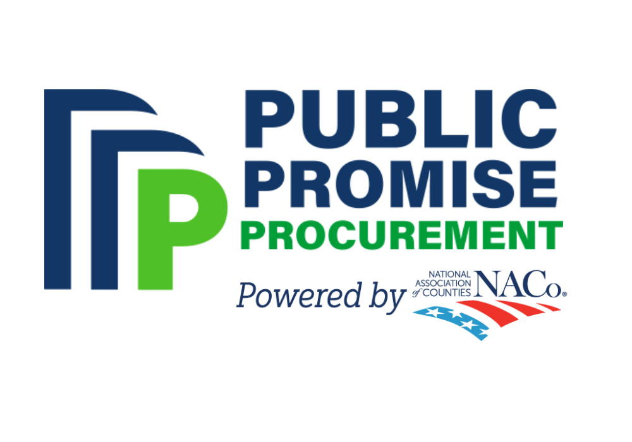OFFICIAL NYSAC ANNOUNCEMNT

To: New York Counties

From: Steve Acquario, Executive Director, NYSAC

Subject: NACo Public Promise Procurement’s Cost-Savings &

Value-Added Solutions for Communities

DATE: [Insert Date]

SUBJECT: **New Public Promise Procurement Contract Available – Government Executive Recruiting Services**

We are pleased to announce a new cooperative purchasing contract available through the National Association of Counties (NACo) Public Promise Procurement (PPP) platform. As a valued member of the New York State Association of Counties, your county can now take advantage of a newly awarded contract for government executive recruiting services, provided by WBCP, Inc. This contract was competitively solicited and awarded by Lead Public Agency (LPA), San Diego County, CA.

**Why Use Public Promise Procurement?**

Public Promise Procurement (PPP) is a cooperative purchasing platform powered by the National Association of Counties, designed to help counties and other public entities streamline procurement while ensuring best-in-class quality and competitive pricing. Each contract is peer-reviewed by an advisory council of procurement experts, ensuring compliance with competitive bid processes and delivering value-driven solutions.

**About the New Contract – Government Executive Recruiting Services**

The newly awarded contract with WBCP, Inc. provides a full range of services, including:

* **Executive Recruitment/Search Services**—specialized recruitment experts for all industries in public sector and geographic locations
* **Partial Search Recruitment Services**—to accommodate every budget and service need
* **Comprehensive Advertising Campaigns**—ensuring you remain competitive in the marketplace, while being branded as an employer of choice!
* **Assessment and Evaluation Tools**—including a competency modeling system designed for the public sector
* **Consulting Services—**including: civil service reform, transforming public sector recruiting to be competitive in the market place, and more!

**How to Utilize This Contract**

We strongly encourage your procurement professionals and human resources teams to explore this new contract and determine if it meets your county’s needs. WBCP, Inc. will also be offering educational webinars to provide additional information on the contract and guide counties on how to purchase from it.

To learn more about this contract and other available cooperative purchasing opportunities, visit the supplier contract page at <https://wbcpinc.com/naco/>, or contact their recruiting team at [HRSolutions@wbcpinc.com](mailto:HRSolutions@wbcpinc.com) or 866-929-WBCP (9227).

By leveraging PPP contracts, your county can save time and resources while benefiting from a transparent, competitively bid procurement process that aligns with public sector best practices.

If you have any questions or would like additional information, please do not hesitate to contact Mark LaVigne ([mlavigne@nysac.org](mailto:mlavigne@nysac.org)) or reach out to NACo’s Public Promise Procurement team directly through Anthony Chapman, <mailto:achapman@naco.org>.

Sincerely,

Steve Acquario

Executive Director

New York State Association of Counties